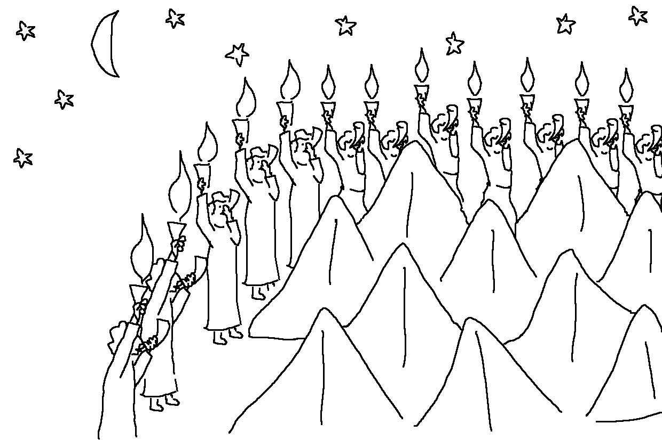
It is not by _ _ _ _ _, nor by _ _ _ _ _ _ _ _, but by My _ _ _ _ _ _, says the Lord of Heaven’s Armies. Zechariah 4:6_{NLT}

